ДАНА КЕНДЫБАЕВА LAB7

**create database** lab7;  
**create table** locations(  
 **location_id serial primary key**,  
 **street_address varchar**(25),  
 **postal_code varchar**(12),  
 **city varchar**(30),  
 **state_province varchar**(12)  
);  
**create table** departments(  
 **department_id serial primary key**,  
 **department_name varchar**(50) **unique**,  
 **budget int**,  
 **location_id int references** locations  
);  
**create table** employees(  
 **employee_id serial primary key**,  
 **first_name varchar**(50),  
 **last_name varchar**(50),  
 **email varchar**(50),  
 **phone_number varchar**(20),  
 **salary int**,  
 **manager_id int references** manager,  
 **department_id int references** departments  
);  
**create table** job_grades(  
 **grade char**(1),  
 **lowest_salary int**,  
 **highest_salary int**);  
**create table** manager(  
 **manager_id serial primary key**,  
 **manager_name varchar**(50)  
);  
**insert into** locations (**city**, **state_province**) **values** (**'ala'**, **'hjhk'**),  
 (**'ast'**, **'hkhk'**),  
 (**'shym'**, **'hjhk'**),  
 (**'karg'**, **'hkhk'**),  
 (**'nyc'**, **'hkh'**),  
 (**'ds'**, **'london'**);  
**insert into** departments (**department_name**, **location_id**) **values** (**'small'**, 4),  
 (**'mega'**, 5),  
 (**'silkway'**, 4),  
 (**'globus'**, 1),  
 (**'walmart'**, 6),  
 (**'ikea'**, 6);  
**insert into** employees (**department_id**, **first_name**, **last_name**, **manager_id**, **salary**) **values**

(3, **'first'**, **'qqqq'**, **null**, 1350),

(1, **'second'**, **'bjj'**, 3, 1200),

(2, **'third'**, **'aab'**, 5, 900),

(3, **'forth'**, **'aabaa'**, **null**, 1050),

(4, **'fifth'**, **'aaa'**, 1, 1400),

(4, **'sixth'**, **'baaa'**, 2, 2000),

(5, **'seven'**, **'fdse'**, 3, 1000),

(6, **'eight'**, **'ferq'**, 4, 1900),

(6, **'nine'**, **'qeqe'**, 1, 1543),

(5, **'ten'**, **'uipop'**, 2, 888);  
**insert into** manager(**manager_name**) **values** (**'alan'**),  
 (**'kim tan'**),  
 (**'aika'**),  
 (**'julia'**),  
 (**'fred'**);  
**insert into** job_grades **values** (**'a'**, 800, 1300),  
 (**'b'**, 1301, 1500),  
 (**'c'**, 1501, 2100);  
*--3***select** e.**first_name**, e.**last_name**, e.**department_id**, l.**city**, l.**state_province from** departments **d  
 inner join** locations l **on d**.**location_id** = l.**location_id  
 inner join** employees e **on d**.**department_id** = e.**department_id  
 where last_name like '%b%'**;  
*--4***select d**.**department_name**, l.**city**, l.**state_province from** locations l **inner join** departments **d on** l.**location_id** = **d**.**location_id**;  
*--5***select** e.**first_name**, **m**.**manager_name from** employees e **left join** manager **m on** e.**manager_id** = **m**.**manager_id**;  
*--6***SELECT** j.**grade**,  
 *count*(*\**),  
 *avg*(**salary**)  
**FROM** employees e   
 **join** job_grades j **on** e.**salary   
 BETWEEN** j.**lowest_salary AND** j.**highest_salary   
group by** j.**grade**;  
*--7***select** e.**first_name**, e.**last_name**, l.**city from** departments **d  
 inner join** locations l **on d**.**location_id** = l.**location_id  
 inner join** employees e **on d**.**department_id** = e.**department_id  
 where** l.**city** = **'london'**;

#3

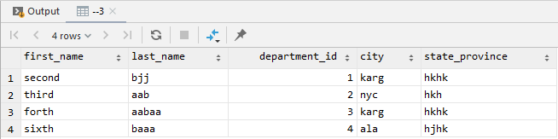

#4

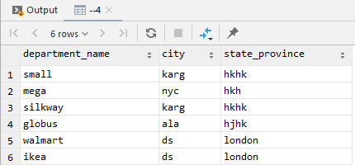

#5

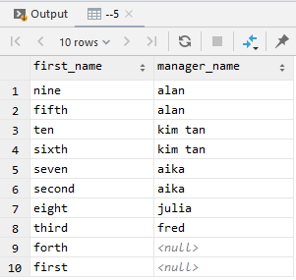

#6

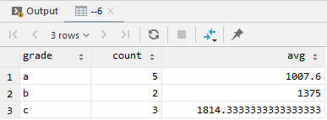

#7

